Simple Factory
(Creational - Pseudopattern)

We use the prefix pseudo because the simple factory isn’t actually considered a pattern in the Gang of Four book.
The simple factory is essentially a class that, based on a given input, returns objects of different types.
In contrast to the factory method or the abstract factory, the simple factory is made up of just one concrete factory. This concrete factory doesn’t inherit from another abstraction layer.

To illustrate this pattern, let’s consider we’re a company that builds computers. For the moment, we’re only producing laptops.

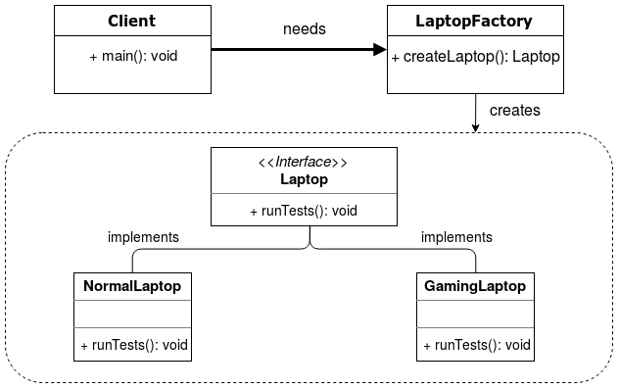

Pros
- the same advantages mentioned for the factory method pattern such as encapsulating object creation apply.

Cons
- if a new type of Laptop is added to the system, then we’d also need to change the logic, i.e. switch statement, in the createLaptop() method below. This can be avoided with the factory method pattern.

Step 1
public interface Laptop {
void runTests();
}

Step 2
public class NormalLaptop implements Laptop {
@Override
public void runTests() {
System.out.println("Running tests on a NormalLaptop...");
}
}

public class GamingLaptop implements Laptop {
@Override
public void runTests() {
System.out.println("Running tests on a GamingLaptop...");
}
}

Step 3
public class LaptopFactory {

// Objects are created here
public Laptop createLaptop(String laptopType){
if (laptopType == null) {
return null;
}

switch (laptopType.toUpperCase()) {
case "NormalLaptop":
return new NormalLaptop();
break;
case "GamingLaptop":
return new GamingLaptop();
break;

default:
return null;
}
}
}

Step 4 (output)
Running tests on a GamingLaptop...
Resources:
https://dragonprogrammer.com/design-patterns-java-simple-factory/

